The State Machine Framework

Security Classification: | Internal
Document Reference: | N/A
Status: | Issued
Version: | 1.0
Team/Department : | Core Development\Networking
Author(s): | Petr Smrz
Owner(s): | Networking TA

Approver(s): | Networking TA | Distribution:

Contents
1 Introduction 3
1.1 Purpose and Scope 3
2 Design Overview 3
2.1 Design Goals 3
2.2 Solution 3
3 Detailed Design 4
3.1 UML 4
3.2 Design Unit Behaviour 5
3.2.1 CStateMachine start-up 5
3.2.2 CStateMachine description 5
3.2.3 CStateMachine::RunL 6
3.2.4 Building an event chain 6
4 Design Considerations 6
4.1 Cancel 6
5 People 7
6 References 7
7 Open Issues 7
7.1 Glossary 7
7.2 Document History 7

Introduction

Purpose and Scope
This document provides an abstraction of the state machine framework offering error handling, cleanup actions and the way to design the states. The document is a part of networking base used to create networking components. The target audience is members of the Networking Team developing new components or maintaining the old ones.

Design Overview
The design itself is simple consisting from just two classes and on notification interface.

Design Goals
These are the presented framework goals
- Asynchronous state processing facilitation
- Error handling, either via leave or request completion with an error
- Clean up state support
- Notification via client request completion or(and) notifier interface
- Possibility to reflect hierarchical states in the code.
Since the state machine is asynchronous, (the new state becomes active when the current one has completed request status) we say that the state is one asynchronous event.

Solution
The main idea is to represent state by an abstract class CAsynchEvent. Every class derived from it can be a state machine event (state). This doesn’t stop this particular class being a state machine itself, as we will see later. Each derivative must implement ProcessL virtual method. The method takes request status to be completed and returns a pointer to the incoming event or NULL if the task of the particular state machine has been completed. The state machine framework itself is represented by a class CStateMachine.
Advantages:
- State specific logic is clearly separated into classes rather than strewn over huge class
- Uniform error handling and completion signalling so we clearly know where state machine ends and different processing starts. It should prevent users from having TRAP harnesses everywhere.
- Allows the complex functionality be divided into levels. An example would be TLS when one event can have two or three simple closely related states (level one). The event classes create a chain (level two). The way the events are chained can be static (set before the state machine starts) or dynamic set on the fly according to the state machine history (level three).

Disadvantages:
- Each instance representing an event is allocated dynamically on heap

Detailed Design
This section attempts to give a detail insight into how the classes co-operate with each other.

UML
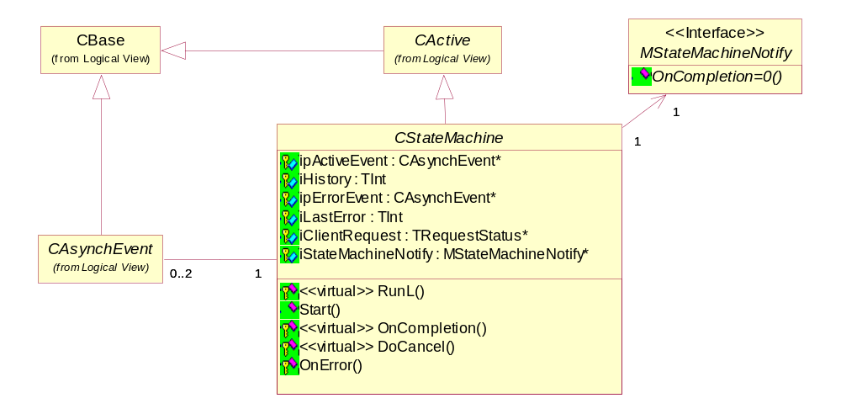

Figure 3-1 State machine class layout

Object name | Description | Associated (owned/dependant) objects
CAsynchEvent | Abstract base for an asynchronous event processed by a CStateMachine class. Each derivative represents one event (asynchronous state) | CAsynchEvent* - a reference to the next event created statically or dynamically  CStateMachine*- a reference to the state machine which runs the event
CStateMachine | A state machine base class. | CAsynchEvent* - as an active event  CAsynchEvent* - event to become active when an error occurs  MStateMachineNotify* - interface used to notify upon completion or suspension
MStateMachineNotify | If registered with the CStateMachine instance it will be notified on completion or suspension. The idea behind MStateMachineNotify interface is to allow classes, which are not derived from CStateMachine, to control a completion and suspension.
Table 3-1 State Machine classes

Design Unit Behaviour
The base classes for the state machine (CAsynchEvent and CStateMachine) are designed as a generic model for processing asynchronous events one by one that can be linked together or created/destroyed on the fly. Cleanup and error handling is provided by CStateMachine class. The CStateMachine::RunL() function calls CAsynchEvent::ProcessL() which returns either the next event or NULL. NULL indicates that the task the state machine has been started for is finished, with an error code stored in CStateMachine::iLastError. Upon completion the virtual CStateMachine::OnCompletion method is called and MStateMachineNotify::OnCompletion is called. If the last method returns ETrue the state machine will delete itself. The main idea behind the CStateMachine::RunL function is to have error and exception handling, related to the state machine task, in one place rather than scattered around the code. The solution allows the events’ processing code to leave, or complete request with an error, if something unexpected happened and let the RunL function cope with the problem. The function serves a cancel request as if it were an error. The state machine does not own the active event and the error event objects, it is the users’ responsibility to free the objects’ memory as appropriate. Please see [1] Use Case view/CStateMachine::Cancel and CStateMachine::RunL for details on functionality of these two functions.

CStateMachine start-up
To start state machine the user must do the following:
- Create CStateMachine class derivative
- Create starting event (state) and set it as an active event
- Set CStateMachine’s history to the desired value
- Call CStateMachine::Start
The state machine can be suspended meaning that when the currently processed event completes and the RunL method returns without calling the active event ProcessL method. In that case, the notifier object (MStateMachineNotify) is notified but the client request is not completed and the state machine is frozen.

CStateMachine description
The state machine itself operates with two status requests:
- The one which is given to it as a parameter of CStateMachine::Start method and completes when the state machine has finished the task
- The iStatus member of the CActive base class, which is being passed to CAsynchEvent::ProcessL and whose completion causes CStateMachine::RunL being called by CActiveScheduler.
Once the particular state machine has been initialised and started (see 3.2.1). The CStateMachine::Start method just completes the state machine request to make the active scheduler call CStateMachine::RunL for the first time. Since then it runs being called by CActiveScheduler upon completion of CStateMachine::iActive->ProcessL asynchronous call that takes CStateMachine::iStatus as a parameter and returns pointer to a new CActiveEvent derived class.
The CStateMachine has the following attributes:
- iActiveEvent - a pointer to active CAsynchEvent derived class that says which state the state machine is in.
- iErrorEvent - a pointer to a CAsynchEvent derived class which becomes an active event when an error occurs. If the error event is NULL than the state machine completes with the iLastError.
- iHistory - TInt value to keep a track of what has happened in form of bit flags.
- iSuspendRequest - TBool if this is ETrue the state machine is “frozen”, after currently pending asynchronous event has finished, until restarted (via CStateMachine::Start())
- iLastError - TInt value holding error code history
On completion (the last CAsynchEvent::ProcessL() returns NULL), the state machines complete the request given as a parameter to CStateMachine::Start() and calls OnCompletion virtual method.
The ProcessL() is required to do one and only one of the following:
- Complete given request status before return
- Pass given request further on for competition and return
- Leave with an error
One single event class can be a “sub-state machine” itself in case when handling a single event is more complex and very closely related so that it can be viewed as a sub-task. The so called “sub-state machine” is supposed to be very straightforward having up to three states. Another possibility would be to start a “child” sub-state machine, from within an active ProcessL call, derived from CStateMachine class running list of CAsynchEvent(s) to handle one parent state machine’s event. The last mentioned possibility would account for a very complex state machine. As such, it is not very likely to ever occur.

CStateMachine::RunL
This is one of the most important methods of the design that is why this special heading. On entry it checks iStatus and does the following:
- iStatus OK - It checks whether it has completed the state machine task (mostly the state machine derived class dependent), this is indicated by iActiveEvent == NULL. If so it calls OnCompletion method, completes given request (in Start function) with iLastError and returns. If not it checks iSuspendRequest and calls iActiveEvent->ProcessL if not suspended
- iStatus ERROR - It checks whether iLastError has been already set:
- iLastError == KErrNone - sets the iLastError to iStatus, sets iActiveEvent be iErrorEvent and calls iActiveEvent->ProcessL() to react to the error conditions.
- iLastError != KErrNone - this could mean either that the point 1 has already happened but completed with an error or CActive::Cancel has been called. (See [4] CStateMachine Cancel action diagram) which is indicated by iActiveEvent being equal to iErrorEvent. Dependent on what applies, it either calls iActiveEvent(==iErrorEvent)->ProcessL() to send an alert to indicate the cancel or calls OnCompletion and completes given status with iLastError

Building an event chain
This is entirely up to the application. Such examples could be TLS state machine or DHCP state machine. Please refer to either implementation for a code example.

Design Considerations

Cancel
The current design assumes that whatever asynchronous objects are involved in the particular event’s asynchronous processing they are all seen by the current state machine class (CStateMachine derivative). If that holds, then the state machine itself can call Cancel method for all objects possibly involved having no knowledge of what is actually being involved. Wouldn’t it be better to introduce another virtual method CAsynchEvent::Cancel (doing nothing by default) and make CStateMachine base class to remember a pointer to the pending event? See 7 Open Issues.

People

Role | Person / People
Contributor(s) | Kevin Benton
Reviewer(s)

References
No. | Document Reference | Version | Description
[1] | State Machine Design | 1.0 | The State Machine UML model
[2] | DHCP code |  | Element usage example
[3] | TLS code |  | Element usage example

Open Issues
The following issues need to be resolved before this document is completed:
- What would be the best way to cancel currently ongoing active event?

Glossary
The following technical terms and abbreviations are used within this document.
Term | Definition

Document History
Date | Version | Status | Description
07-04-2003 | 0.1 | Draft | First draft
06-02-2004 | 1.0 | Issued | Updated and issued after review

